**Nama : Dini Tri Widianingsih**

**No. Peserta : FSDO003ONL007**

**PANDUAN SESI 10**

**TodoAppWithJwt**

1. Tampilan Awal Swagger

LINK : <https://localhost:5001/swagger/index.html>

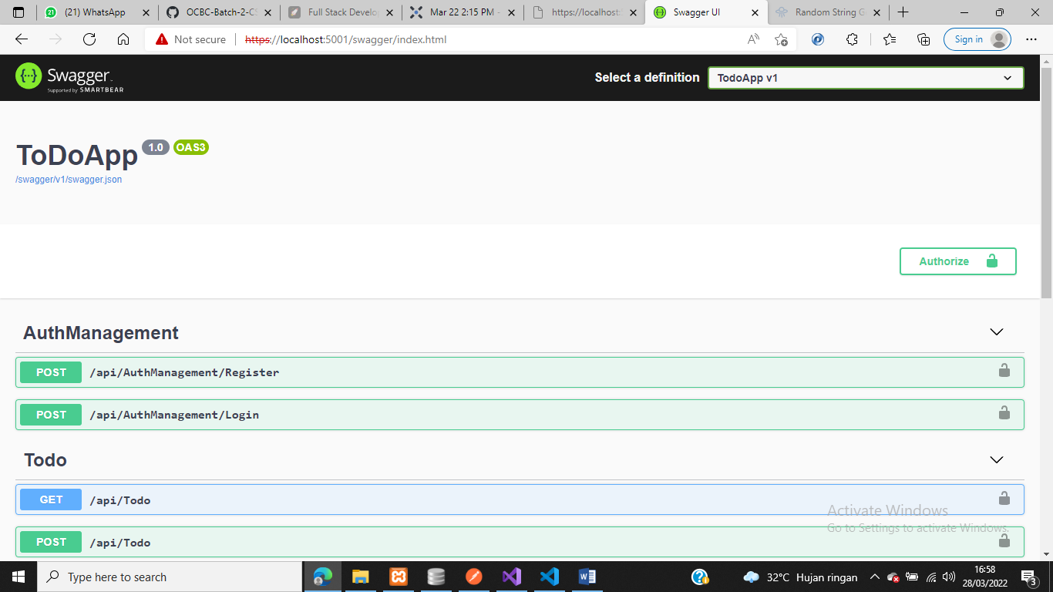

1. Register

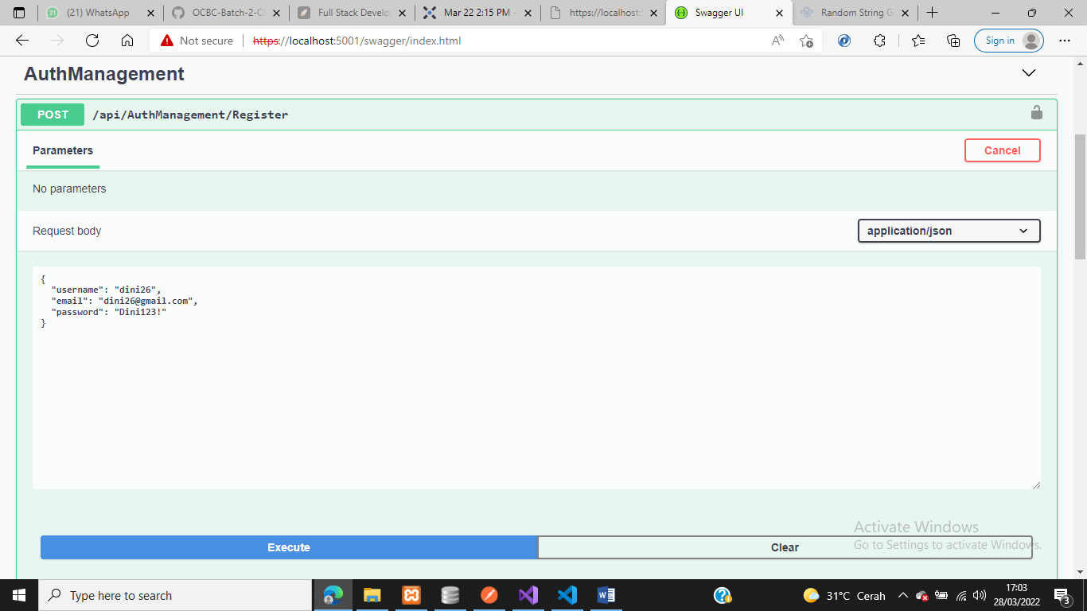

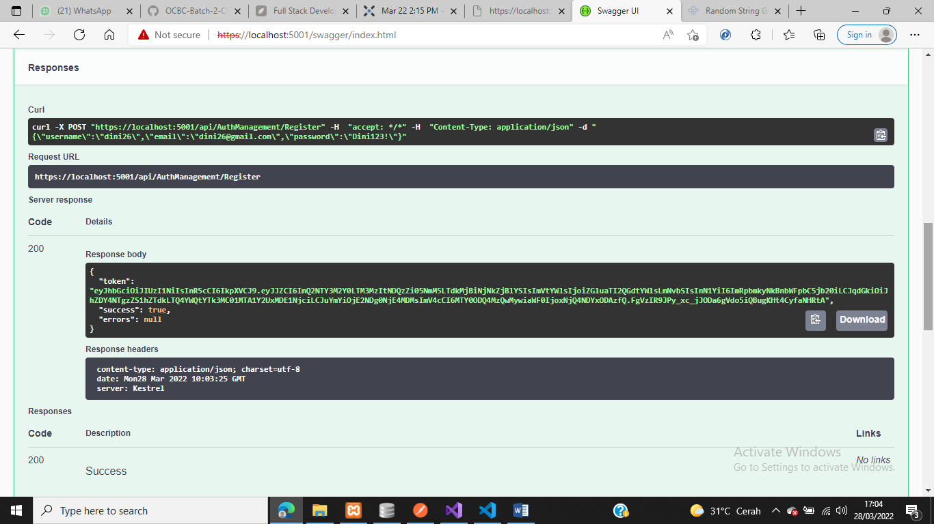

1. LOGIN

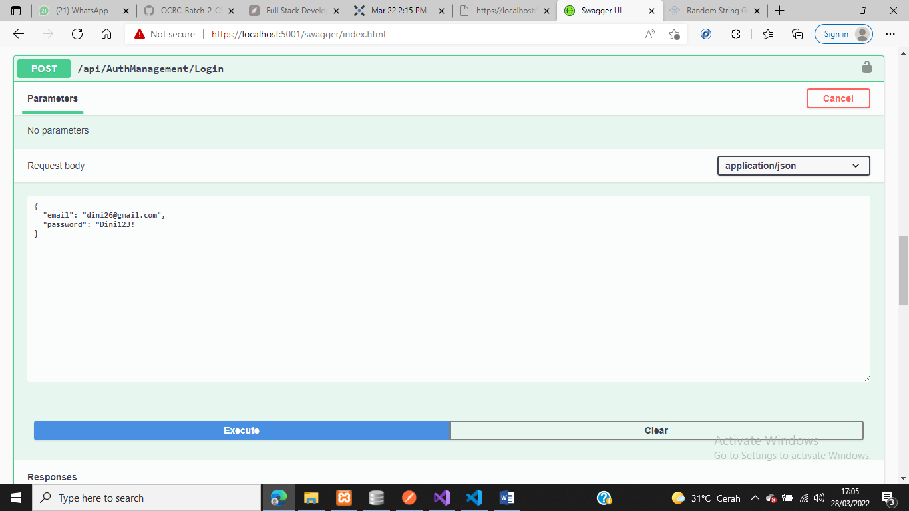

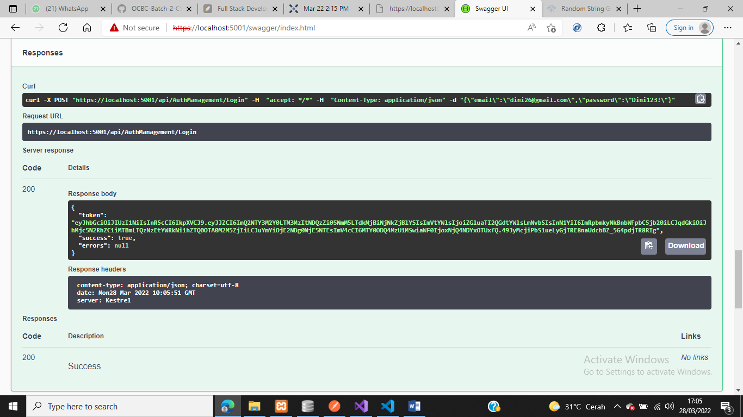

1. GET

* Authorize

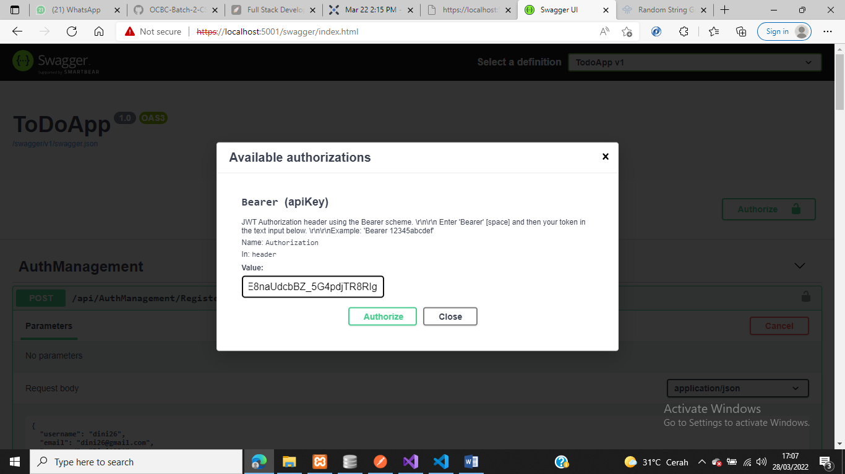

* Hasil GET

